Project Design Phase-I Solution Architecture

Date | 06 March 2026
Team ID | 699d5f96c40b5ad0e9ee5a06
Project Name | Malaria Detection using Deep Learning
Maximum Marks | 4 Marks

Solution Architecture:

For the AI-Based Malaria Detection System, the solution architecture provides a structured framework that connects the healthcare problem of malaria diagnosis with an automated artificial intelligence solution. The system leverages deep learning techniques to analyze microscopic blood smear images and detect malaria infection efficiently.
Its primary goals are to:
* Map the healthcare requirement of early malaria detection to a technical workflow using an automated deep learning image classification pipeline.
* Illustrate how microscopic blood cell images flow from the user interface through preprocessing, model inference, and prediction generation.
* Define the technologies used in each phase of the system including Python, TensorFlow/Keras, Flask, and web technologies (HTML, CSS, JavaScript).
* Provide a clear and scalable architecture that allows the system to be deployed in clinics, hospitals, and research environments for faster diagnosis.

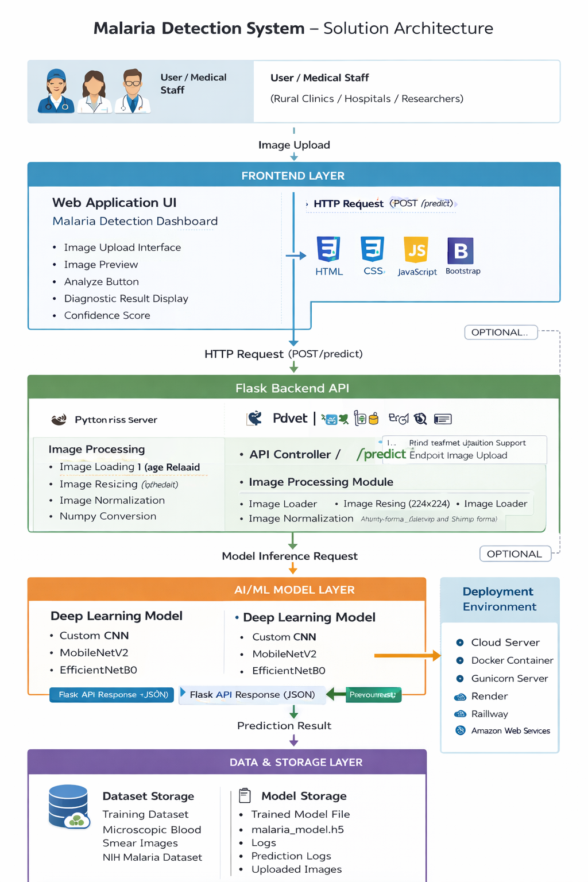
Figure 1: Architecture and data flow of the AI-Based Malaria Detection System

